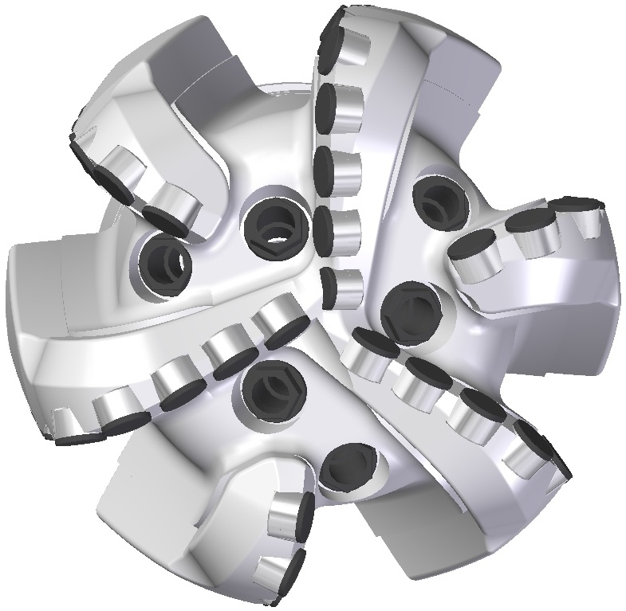 |  | 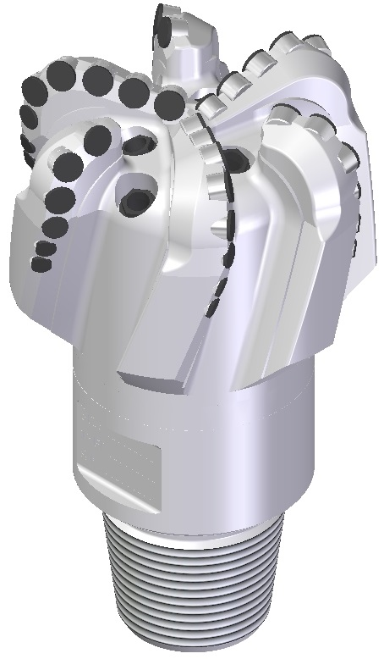

Drill Bit Specifications:
Cutter Size (Primary, Sec) | 3/4”,5/8",1/2”
Cutter Count (Total, Gage) | 24,7,12
Blade Count | 6
Gage Length (Inches) | 3.00
Nozzle Count (Primary, Sec.) | 6
Nozzle Series (Primary, Sec.) | 60
JSA (Sq. Inches) | 20.16
Max. TFA (Sq. Inches) | 2.23
Operating Parameters:
Max Hydraulic Flow Rate (GPM) | 670
Max. Weight on Bit (1,000 Lbs.) | 37
Make-up Torque (ft/lbs) | 16,488
Nominal Dimensions:
Overall Length (Inches) | 15.375
Make Up Length (Inches) | 11.250
Bit Breaker | SKB-21010
Connection | Ø4-1/2" API Reg.
Approx. Weight (Lbs.) | 115

Standard Features:

- Large open face volume assists cuttings removal
- Six nozzles optimize blade cleaning and cuttings removal
- Premium grade cutters maximize ROP and Life

619-SR Nomenclature Explained:

- 6 = Number of blades
- 19 = Primary Cutter Size
- SR = Single Row of Cutters

